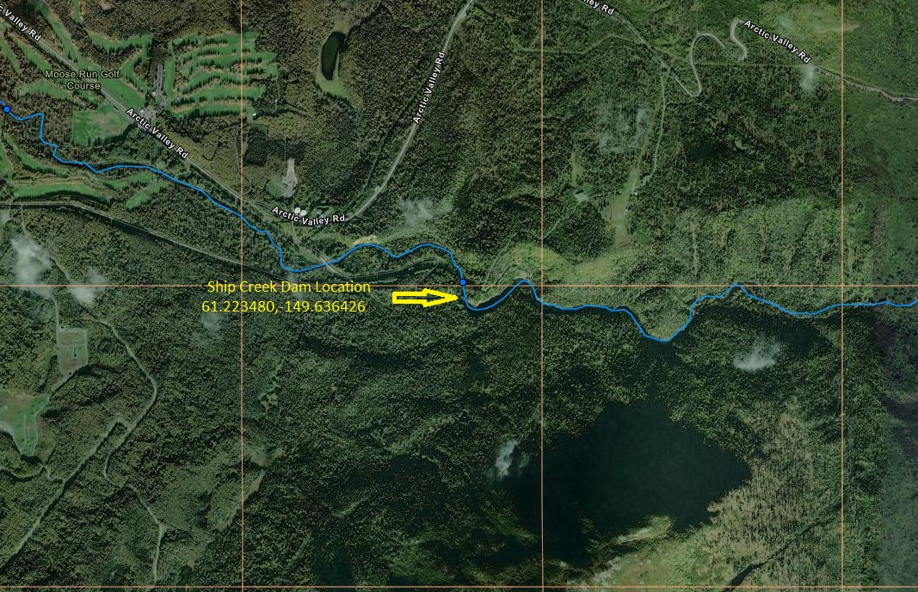
Ship Creek Doyon Dam Location

